**Project Initialization and Planning Phase**

|  |  |
| --- | --- |
| Date | 01-07-2024 |
| Team ID | 739697 |
| Project Name | Fetal AI: Using Machine Learning To Predict And Monitor Fetal Health |
| Maximum Marks | 3 Marks |

**Define Problem Statements (Customer Problem Statement Template):**

The current process of monitoring fetal health poses significant challenges for healthcare providers and expectant parents, impacting their peace of mind and overall satisfaction. Common challenges include limited access to timely and accurate fetal health data, lack of personalized care, and cumbersome monitoring systems. These challenges can lead to increased anxiety and potential health risks for both the mother and fetus. To enhance the healthcare experience and ensure better outcomes, we aim to address these pain points by utilizing machine learning to predict and monitor fetal health. By understanding the specific frustrations during the monitoring process and implementing AI-driven solutions, we can create an efficient, userfriendly experience that aligns with the needs and expectations of expectant parents, fostering a positive relationship with our healthcare services.

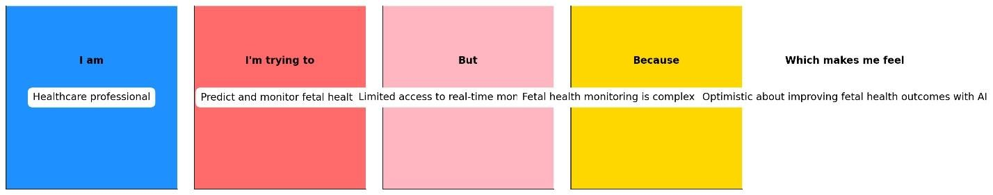

|  |  |  |  |  |  |
| --- | --- | --- | --- | --- | --- |
| **Problem**  **Statement**  **(PS)** | **I am** **(Customer)** | **I’m trying to** | **But** | **Because** | **Which makes me feel** |
| PS-1 | An expectant parent | Ensure the health and well-being of my unborn child | Limited access to accurate fetal health data | Concerned about potential  health risks | Anxious and worried about the health of  my baby |